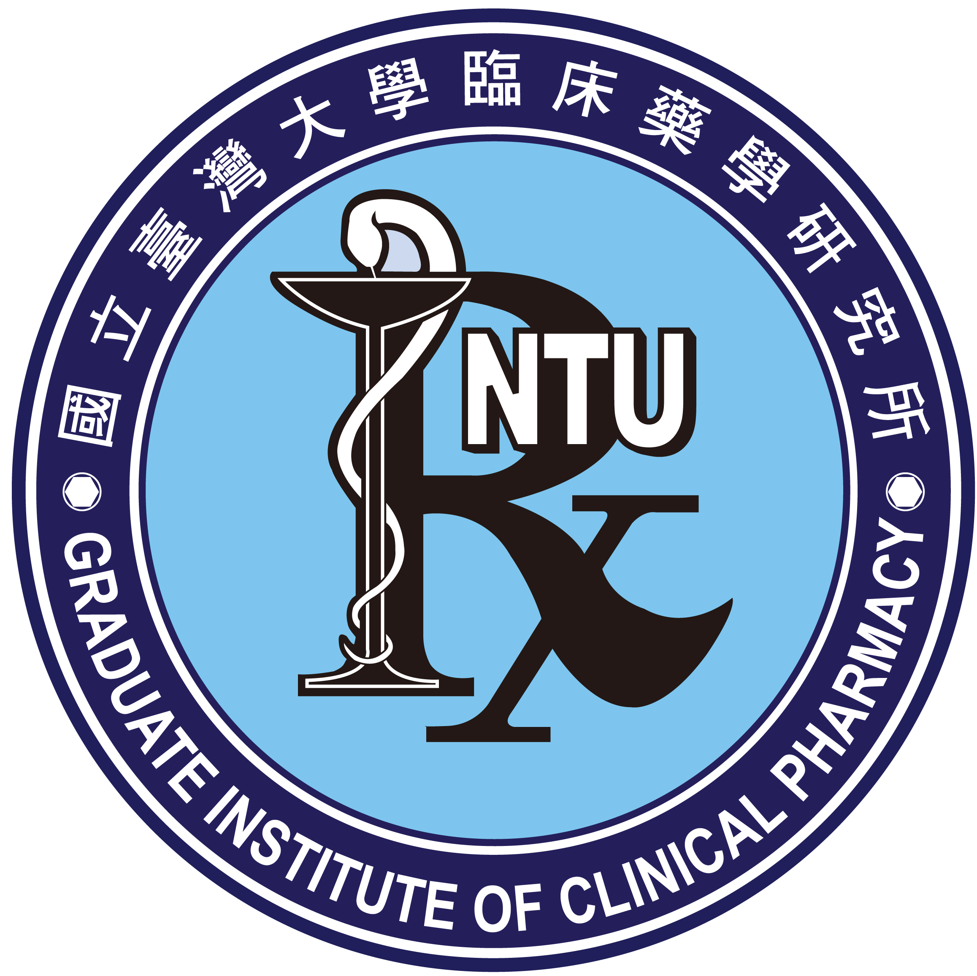 | 國立臺灣大學醫學院臨床藥學研究所誠徵教師

- 應徵資格：
申請者須具開創性、獨立性、團隊合作精神及中英文授課能力，且需符合下列條件：
- 專長為下列領域之一：
  - 臨床藥學（clinical pharmacy）
  - 藥物基因體學（pharmacogenomics）
  - 臨床藥物計量學（clinical pharmacometrics）
  - 臨床藥物資料科學（data science in clinical pharmacy）
  - 社會藥學（social pharmacy）
- 具有相關領域之博士學位，以具有博士後研究資歷或臨床藥學實務經驗者尤佳。

- 檢具下列資料：除推薦函外，請寄電子檔
- 個人履歷。
- 學經歷證件。
- 五年內（110.2.1～迄今）代表性著作（最多五篇）。
- 完整著作目錄。
- 未來三年教學及研究計畫概要。
- 其他有助於瞭解申請者背景之資料。
- 推薦函三封（由推薦人逕寄送電子檔或紙本至臨床藥學研究所黃織芬所長，E-Mail: cfhuang1023@ntu.edu.tw）。
前第1~5、7項資料不全者，不予受理。

- 截止日期：114年7月31日下午五時前送達臺大臨床藥學研究所
(四)起聘日期：115年2月1日
(五)來函請寄：100025臺北市中正區林森南路33號209室
臺大醫學院臨床藥學研究所新聘教師甄選委員會召集人
黃織芬所長 收
傳真專線:(02) 3366-8780
E-Mail: ntugiocp@ntu.edu.tw

National Taiwan University
Graduate Institute of Clinical Pharmacy
Assistant/Associate/Full Professor of Clinical Pharmacy

A tenure track faculty position of an Assistant, Associate or Full Professor Rank is open at the Graduate Institute of Clinical Pharmacy, NTU. The appointment will begin in February 2026.

- Qualifications:
Applicants must be innovative, independent, team-oriented, and proficient in teaching in both Mandarin and English. They must meet the following criteria:
  - Expertise in one of the following areas:
- Clinical pharmacy
- Pharmacogenomics
- Clinical pharmacometrics
- Data science in clinical pharmacy
- Social pharmacy
  - A Ph.D. in a related field, with postdoctoral research experience or practical experience in clinical pharmacy being an advantage.
- Required Documents (except recommendation letters, all documents should be sent electronically):
- Curriculum vitae.
- Certificates of education and professional experience.
- Up to five representative publications from the past five years (from February 1, 2021, to the present).
- List of publications.
- A summary of teaching and research plans for the next three years.
- Any other materials that can help understand the applicant's background.
- Three letters of recommendation (to be sent directly by the recommenders either electronically or in hard copy to Director Chih-Fen Huang at E-Mail: cfhuang1023@ntu.edu.tw).
Incomplete applications will not be considered if items 1 to 5 and 7 are not fully provided.
- Deadline: Applications must be received by the Graduate Institute of Clinical Pharmacy, NTU, by 5:00 p.m., July 31, 2025.
- Appointment Date: February 1, 2026.
- Mailing Address for Correspondence:
Room 209, No. 33, Linsen South Road, Zhongzheng District, Taipei City 100025,
Chair of the Faculty Search Committee, Graduate Institute of Clinical Pharmacy, College of Medicine, NTU, Prof. Chih-Fen Huang,
Fax: 886-2-3366-8780, E-Mail: ntugiocp@ntu.edu.tw.

